Version B1.1

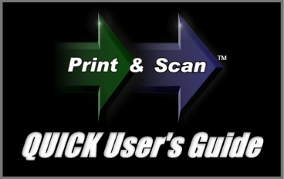

Congratulations on downloading the ZIP-scan PrintScanScore test correction solution!

Installation Instructions


YOU MUST FIRST HAVE A PRINTER/SCANNER INSTALLED AND FUNCTIONAL ON THE COMPUTER THAT WILL BE USING THE PROGRAM! The PrintScanScore program does NOT contain any printer or scanner drivers. The program will use the existing TWAIN drivers that are automatically loaded when you correctly install your scanner on your PC. If you do not have a functional printer/scanner installed DO NOT CONTINUE WITH THE INSTALLATION! There is an option later in the Multi Page Scanning screen to select the correct driver if you have more than one installed. Look for the button and click it to select the driver.

You have downloaded the software in a zipped format from the www.ZIP-scan.com web site. When you double click the icon for the program, the installation process will begin. When you are asked where you want to install the software, do not install it into the default Program Files folder. Create first a folder named "ZIP-scan" on the C: drive and then be sure to install the program into this folder. This will enable all the scanned files you will be creating to be better handled. Using a new folder is essential for Window 7 and VISTA users.

We have integrated the Test Wizard program which we have sold for over 8 years with the new full sheet optical scanner capability in PrintScanScore. There are many advanced features in this software that you will not use. You can simply disregard these features by following this guide and focus on the basic test correction and report generation capability.

This is the Quick User's Guide. These instructions will enable you to quickly experience the success of Printing, Scanning, and Scoring your test sheets.
Below is the image of the initial Welcome screen. We'll start by setting up and printing the test forms.

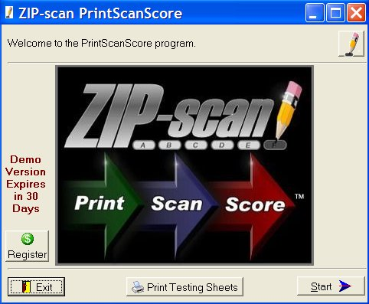

Click at the bottom and the following screen appears:

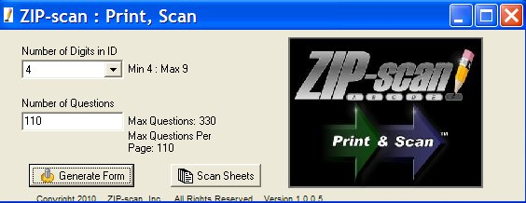

Note the Number of Digits in ID option. As you select from 4 to 9 digits, please note the number of Max Questions changes and the number per page changes. For each increase in the number of ID digits, the number of questions that fit on the page decreases by two. Four digit ID forms have 110 questions per page and the 9 digit ID forms have 100 questions per page. If you specify more questions than will fit on a page, additional pages will automatically be created. Our recommendation is to print full pages of questions so the pages can be used with tests of any number of questions.

Click and the Output Options screen below appears.
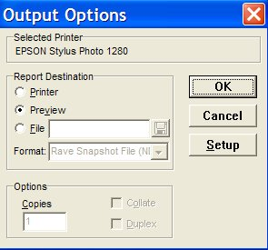


- With Preview selected, click and the form you selected will be displayed on the screen. Click the to return to the first screen.

- With Printer selected, you can print the test sheet you selected that was displayed in the Preview option. Click for the printer, and the box at the bottom of the screen to select the number of copies to be printed.

- With File selected, the drop down menu has a PDF option, and by clicking the , a Browse screen opens and you can select where you want the PDF file to be saved. After you select the Save option in browse to save the location for the PDF, then click to save the PDF file.

The button will not be used since you have the full-featured complete PrintScanScore software. This button is used with the supplemental Print&Scan software that is available when you purchase the PrintScanScore solution. This will enable remote locations to print and scan tests for later scoring at a different location that has the PrintScanScore complete software solution if needed.

After you have printed the test sheets, you need to give a test to your students, or create a practice set of test sheets. (Hint: The software will let you reuse the same practice test sheets multiple times if you change the ID number on the PC screen.) Tests of any size up to 330 questions (for 4 digit ID) are supported. Make sure that your students mark the bubbles darkly. Number 2 Pencils work very well as do ball point pens (blue, black, or red ink), Sharpie markers (fine point), and any dark marking method. The marks must fill most of the bubble and not extend very much beyond the limits of the bubble.

When you are done with the Generate Forms option, click the to return to the Welcome screen. and then click at the bottom right of the screen to open the Configuration screen, which is the first of six tabs in the Test Wizard program that are listed across the top of the screen.

Configuration
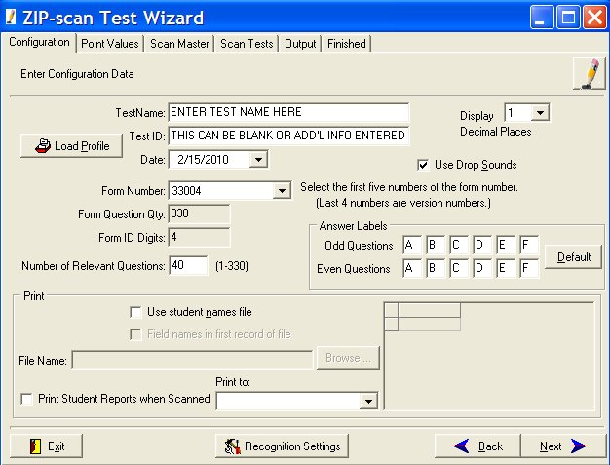

!

!

The Test Name and Test ID fields that you fill in is the information which will be printed on the top of the test reports that are generated by the Test Wizard and the name of the files that will be created.
!
The number in the Form Number field is printed on the left side of the test form that you are going to correct. Look at the test form and get this number correct. It is very important! This five digit number consists of the maximum number of questions that fit on 3 pages (330 for the 4 digit ID test form) and the number of ID digits on the test form preceded by a zero.
!
A second extremely important entry is Number of Relevant Questions. This is the number of questions on the test that you are going to correct. This can be any number from 1 to 330. This number determines how many questions will be corrected (the rest of the sheet is ignored). If this number is larger than one sheet of questions, the required additional sheets will automatically be expected by the software to be scan and scored.

On the right side of the screen near the top is an option for Use Drop Sounds. The default is ON. Each time when a test sheet is scored a sound will be made by the speakers of the PC. This will be discussed in detail later. If you do not want to have a sound, remove the check from this box.
Ignore the rest of the screen for now and click on the bottom right corner of the screen.

Point Value
Ignore the Point Values screen for now (leave values at one point per question) and click .
.

Scan Master
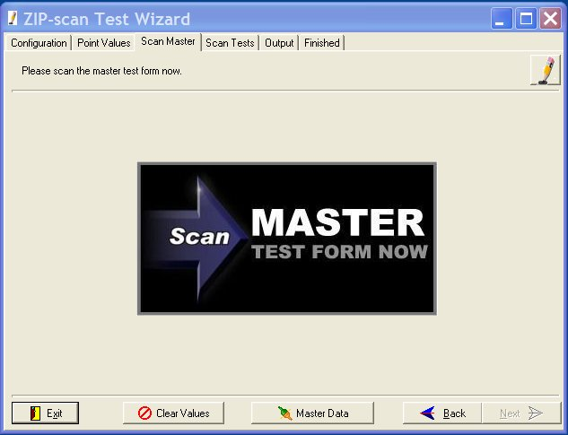

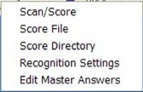

From the Scan Master setup screen, click and a drop down menu will appear. The only option that you need to use now is the top selection: Scan/Score. Select Scan/Score and a Select Folder to Save Image Into screen will appear. Create a new folder for the images that will be scanned and then click .

The Multi Page Scanning screen is displayed. Place the master test form(s) with all of the correct answers marked into the input tray of the scanner. If there is only one scanner accessible to your PC, you are ready to scan the master test form(s). Click and the scanner should initiate the scan of the master test sheet(s). (If no scan occurs, click on the small red image of a scanner at the top left for a drop down menu of all the scanners attached to your PC and pick the scanner that you want to use. If the selection box is blank, either the scanner is not on or is not correctly installed). Then click again. After the scan is completed, the screen will look like the screenshot below:
!

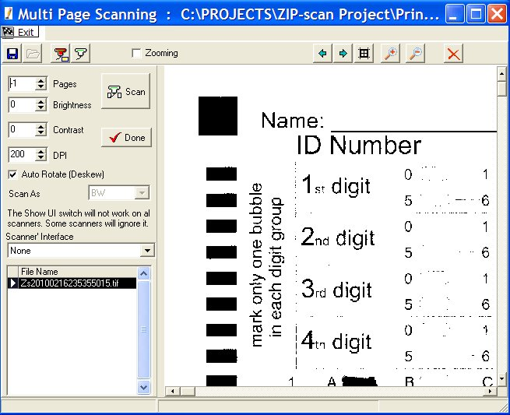

!

You should see the scanned image of the master test form in the large window on the right. There are slider bars on the sides of the image and zoom in/zoom out buttons at the top that enable you to shift the image so you can look at the bubbles that are marked. Are your bubbles dark and are the black squares dark? Even if they are not dark, your scanner should work, but you may need to make an adjustment to the Recognition Settings (discussed later). Please look carefully at the image and remember the appearance of the marks on this page. Enlarge the screen, use the slider bars and the buttons at top of screen to get a good view of the marks on the scanned test sheet. Next click .

The Test Wizard then processes the scan of the master test form(s) and the screen will change as shown below with a one line listing at the top of all the correct answers to the questions. If you have the sound settings turned on, you might hear a "boink" sound, indicating that there was one or more ambiguously marked bubble(s) on the master test form. These will be indicated by a question mark (?) in one or more of the cells (shaded in yellow). The master test form must be corrected and re-scanned with no errors to ensure accurate student comparisons to the master. If the scan was complete with no errors, there will not be a sound created. You can then proceed with the student scoring. YOU HAVE JUST SCORED YOUR FIRST MASTER TEST SHEET! Click to go to the Scan Tests screen. If there are any answers that are indicated as ambiguous, you must either correct the master sheet by adjusting the marked bubble darkness, or follow the instructions in the Recognition Settings section that is next.
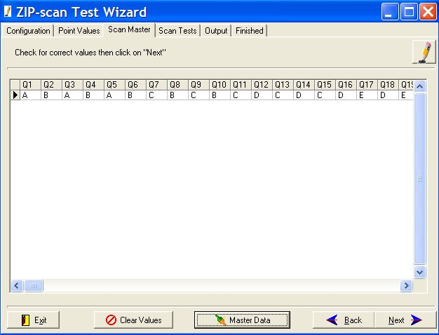

!

Recognition Settings
!
IMPORTANT: If any of the answers are ambiguous, there is a problem that needs to be resolved. (Note: you can edit the screen to correct these answers, but it is best to take the time now to calibrate the scanning function). The scanner should read the master test sheet perfectly. If not, click to display the drop down menu and then select the Recognition Settings option to open the screen as displayed below. (If you are using non-USA size A4 paper, change the PageWidth in inches field to be 8.26 inches).
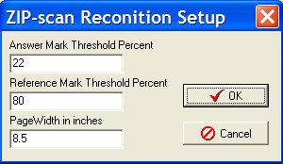

Recall the appearance of the marks on the scanned master test sheet. If the marked bubbles were very dark, then change the Answer Mark Threshold Percent to be 30. If the appearance of the marks was very light, then change the percentage to be 15 or lower. Then click .

Next, click and reload the master test sheet(s) into the scanner. Click select the Scan/Score option and click to scan the sheet again. Click to have the scanned page(s) scored. Inspect the correct answer listing and if it is correct, then proceed by clicking . If there are still problems getting all the question answers to read correctly, go to the end of this User's Guide for additional troubleshooting suggestions.

If the problem is marked bubbles are reading as blank (blue), then decrease the Answer Mark Threshold Percent. If the erased bubbles are being scored as marked (yellow), then increase the percentage.
Click and the Scan Student Test Forms Now screen is displayed.

Scan Tests

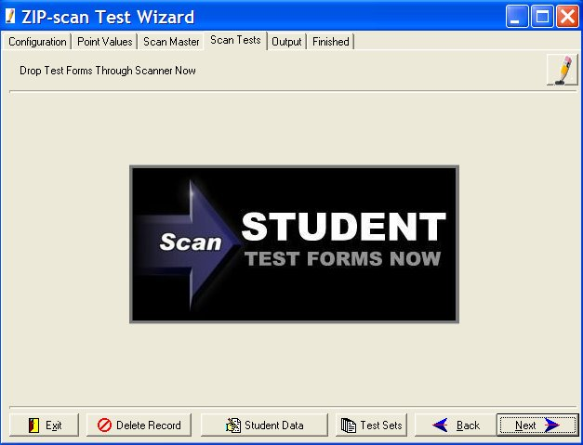

Click at the bottom and in the drop down menu, select the Scan/Score option to bring up the same screen for scanning as used for the master test sheet. This time, if your scanner has an Automatic Document Feeder (ADF), load a stack of student test forms into the feeder and click .
!
Note the -1 value in the Pages field in the upper left of the window below. This -1 value tells the scanner that to enable the ADF feature. If this value is changed to a positive number, the scanner will only scan that number of tests. It is important to leave this value at -1 if you have an ADF!

The scanner should auto feed and scan one test sheet after another. (Note: The demo software program is restricted to only read and score a maximum of five tests). After scanning is completed the screen will look similar to the one below:

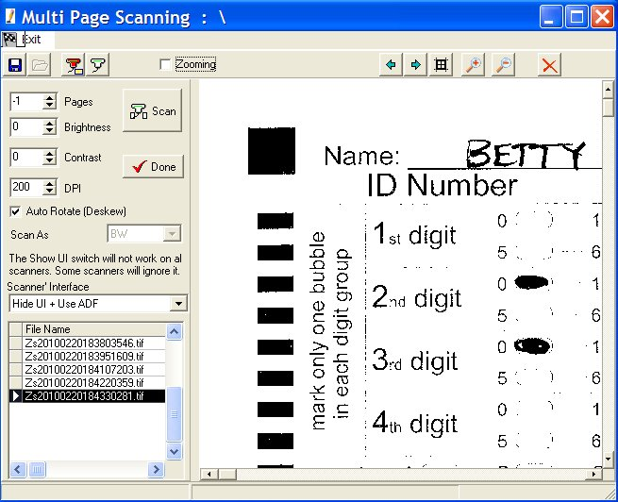

!

This screen is almost identical to the Master Test scan, with the exception that there will be a listing in the left window of each of the tests scanned. The large right window will show an enlarged view of the forms as they are scanned. After the scanner has completed the scan and there are no test forms remaining in the input tray, click . This will start the Test Wizard process which will compare and score the tests based on the Master Test form. After the scoring process is complete, the screen will change and you will see the screenshot shown below.
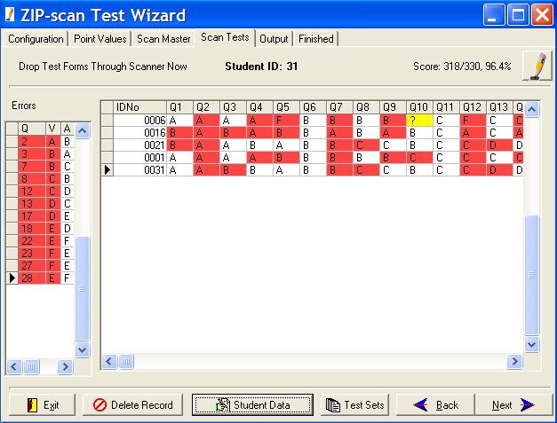
BOINK!
BOINK!

CHIME!

As each student’s test sheet(s) is scored and displayed in the right window, you will hear on the speaker of the PC a pleasant "chime" sound if there are only correct and wrong answers on the test sheet. If you hear an unpleasant "boink" sound, there are questions with a blank response (blue color, hyphen) or an ambiguous (two bubbles marked, yellow color, question mark). Wrong answers are colored red. On the left is a summary of the incorrect responses along with the correct answers listed, and on the top right is the score for the test that has the arrow point opposite its line of data. At the top is the name of the student whose test has the arrow pointed to it if a list of ID numbers and names was created on the second Configuration screen of the software.

Output
Click and the Output screen below is next displayed. For now, ignore everything on this screen except the buttons , , and located near the bottom, Click on these buttons to view the reports.

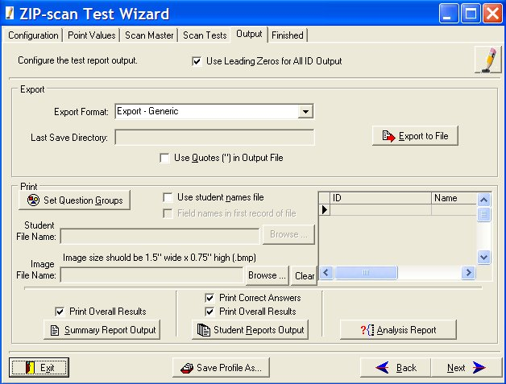

The Analysis Report screen provides the ability to select the sections you wish to include in the report. Also, there is an Export Data option to have the file exported in a tab-delimited format for use in Excel® or similar programs. (Note that the actual export does not occur until an Output option for the Analysis Report is used). For example: select the View option to trigger the generation of the export file.
When you are completely done, click the button at the lower right corner of the screen and you will be able to return to the first Test Wizard screen to begin correcting a new test.

Registration (Activation)
After the 30 day demo period has expired, the on the Welcome Screen will not function.
Contact us to give us your credit card information verbally over the telephone. Or, send us two separate emails with your credit card information split between the emails for security reasons. We are sorry that we do not have a secure server for entering your credit card information. Email and telephone numbers are listed at the end of this Quick User’s Guide document.

You must provide the Machine ID code number that appears at the top of the Register box screen below.

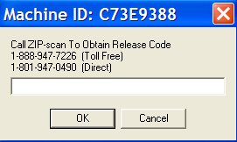

After your credit card payment has been processed, we will use your PC’s Machine ID code to create a Release Code unique to your specific PC. After entering the code, click and the Register Box will disappear. Then exit and restart the program and the button will now be functional.

Troubleshooting

Images
If you cannot scan a page and get an image, then you have a scanner operational problem. Your scanner must be able to function as a scanner using the manufacturer’s supplied drivers before PrintScanScore can function.

You can view the images of the scanned test sheets in the Image folder where you installed the software. If you look closely at the TIFF images, you can usually see why there was a problem with the scoring.

If marked bubbles are being read as blank (blue color, with a hyphen), then you need to decrease the Answer Mark Threshold Percent value until marked bubbles are read properly. (Blue = decrease %)

If there are erasures on a test form that are being read as marks, causing two marks to be read as ambiguous (yellow color with a question mark), then you will need to increase the Mark Threshold Value Percent value so that an erasure will not be identified as a mark. (Yellow = Increase %)

Auto Feed
We had one scanner with an automatic document feeder (ADF) that would not auto feed a stack of test forms. We installed the same driver on a different PC and the ADF worked fine. You may want to try the scanner’s driver program on a different PC if you have a similar problem. Or, download the latest driver from the manufacture’s web site and install to see if it solves the problem.

Drivers
We installed a scanner on a Window 7 PC and the Microsoft drivers for the scanner auto loaded. But, the quality of the images were terrible (little dots all over the image). We then went to the scanner manufacture’s web site and downloaded the latest Windows 7 drivers for the scanner and then perfect scanned images resulted.

Scanners
We have evaluated many all-in-one fax/scanner/printer combination units from Lexmark, HP, Brother, Epson, and Dell and they all worked fine with the PrintScanScore solution. The best value scanner-only product was the Kodak ScanMate i1120 auto 20 sheet-per-minute duplex scanner for less than $400 (www.newegg.com). Alternatively, you could purchase a used scanner and download the drivers from the Internet to get it to function on your PC. We truly believe all TWAIN compliant scanners will function properly with PrintScanScore. And the alternative to TWAIN called WIA usually also works if there is no standard driver in the listing of the scanners attached to your PC that is displayed when the small red scanner shaped button at the top of the scanning screen is clicked.

Macintosh PC
We do not have support for Mac’s. Microsoft has a program called Virtual PC which enables a Mac to function as a Windows PC which our testing indicates works very well.

______________________________________________________________________________________

Please email or call with questions. Especially email as attachments examples of your test sheet images. We want to help you and we are ready to provide assistance.

Email Address: support@ZIP-scan.com

Telephone toll free in USA: 888-947-7226
For outside of the USA: 801-947-0490
Hours: 8:00 AM – 5:00 PM Mountain Time Zone USA, Monday through Fridays

© 2010 ZIP-scan, Inc.

