Version B1.1

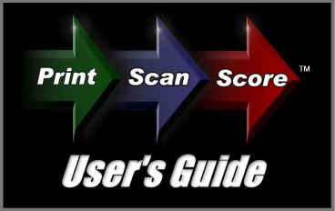

Congratulations on downloading the ZIP-scan PrintScanScore test correction solution!

Installation Instructions

YOU MUST FIRST HAVE A PRINTER/SCANNER INSTALLED AND FUNCTIONAL ON THE COMPUTER THAT WILL BE USING THE PROGRAM! The PrintScanScore program does NOT contain any printer or scanner drivers. The program will use the existing TWAIN drivers that are automatically loaded when you correctly install your scanner on your PC. If you do not have a functional printer/scanner installed DO NOT CONTINUE WITH THE INSTALLATION!

You have downloaded the software in a zipped format from the www.ZIP-scan.com web site. When you double click the icon for the program, the installation process will begin. When you are asked where you want to install the software, do not install it into the default Program Files folder. Create first a folder named "ZIP-scan" on the C: drive and then be sure to install the program into this folder. This will enable all the scanned files you will be creating to be better handled. Using a new folder is essential for Window 7 and VISTA users.

We have integrated the Test Wizard program which we have sold for over 8 years with the new full sheet optical scanner capability in PrintScanScore. There are many advanced features in this software that you will not use. You can simply disregard these features by following this guide and focus on the basic test correction and report generation capability. Note that there is a separate QUICK USER'S GUIDE for those who want to learn the basic features quickly.

Below is the image of the initial Welcome screen. We'll start by setting up and printing the test forms.

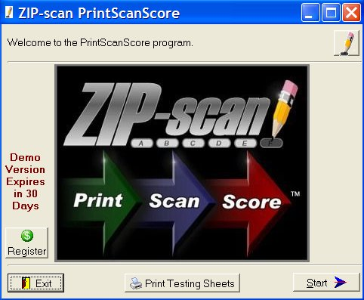

Click at the bottom and the following screen appears:

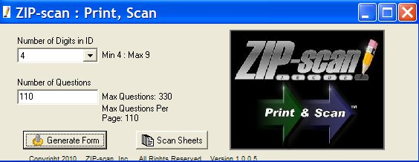

Note the Number of Digits in ID option. As you select from 4 to 9 digits, please note the number of Max Questions changes and the number per page changes. For each increase in the number of ID digits, the number of questions that fit on the page decreases by two. Four digit ID forms have 110 questions per page and the 9 digit ID forms have 100 questions per page. If you specify more questions than will fit on a page, additional pages will automatically be created. Our recommendation is to print full pages of questions so the pages can be used with tests of any number of questions.

Click and the Output Options screen below appears.
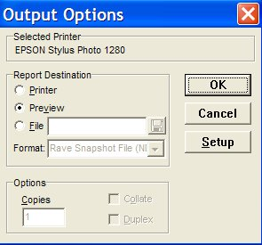


- With Preview selected, click and the form you selected will be displayed on the screen. Click the to return to the first screen.

- With Printer selected, you can print the test sheet you selected that was displayed in the Preview option. Click for the printer, and the box at the bottom of the screen to select the number of copies to be printed.

- With File selected, the drop down menu has a PDF option, and by clicking the , a Browse screen opens and you can select where you want the PDF file to be saved. After you select the Save option in browse to save the location for the PDF, then click to save the PDF file.

The button will not be used since you have the full-featured complete PrintScanScore software. This button is used with the supplemental Print&Scan software that is available when you purchase the PrintScanScore solution. This will enable remote locations to print and scan tests for later scoring at a different location that has the PrintScanScore complete software solution if needed.

After you have printed the test sheets, you need to give a test to your students, or create a practice set of test sheets. (Hint: The software will let you reuse the same practice test sheets multiple times if you change the ID number on the PC screen.) Tests of any size up to 330 questions (for 4 digit ID) are supported. Make sure that your students mark the bubbles darkly. Number 2 Pencils work very well as do ball point pens (blue, black, or red ink), Sharpie markers (fine point), and any dark marking method. The marks must fill most of the bubble and not extend very much beyond the limits of the bubble.

When you are done with the Generate Forms option, click the to return to the Welcome screen. and then click at the bottom right of the screen to open the Configuration screen, which is the first of six tabs in the Test Wizard program that are listed across the top of the screen.

Configuration
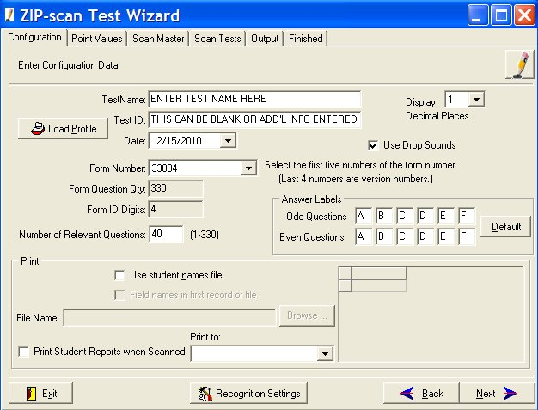

!

!

The Test Name and Test ID fields that you fill in is the information which will be printed on the top of the test reports that are generated by the Test Wizard and the name of the files that will be created.
!
The number in the Form Number field is printed on the left side of the test form that you are going to correct. Look at the test form and get this number correct. It is very important! This five digit number consists of the maximum number of questions that fit on 3 pages (330 for the 4 digit ID test form) and the number of ID digits on the test form preceded by a zero.
!
A second extremely important entry is Number of Relevant Questions. This is the number of questions on the test that you are going to correct. This can be any number from 1 to 330. This number determines how many questions will be corrected (the rest of the sheet is ignored). If this number is larger than one sheet of questions, the required additional sheets will automatically be expected by the software to be scan and scored.

On the right side of the screen near the top is an option for Use Drop Sounds. The default is ON. Each time when a test sheet is scored a sound will be made by the speakers of the PC. This will be discussed in detail later. If you do not want to have a sound, remove the check from this box.
Ignore the Answer Labels and Load Profile sections in the middle for now. They will be discussed in the Advance Feature section later in this manual.

We will cover the Print section in detail now. Check the box Use student names file if you want the names of the students included automatically on the reports. (You will need to create a simple .txt data file with the WordPad program included in the Accessories programs of Windows). This data file will list on each line a student’s ID number, then <tab>, then the student’s name. Use one line for each student. Click
and find the file you created. Next click . If you are successful, the data will appear to the right with headings of ID and Name.

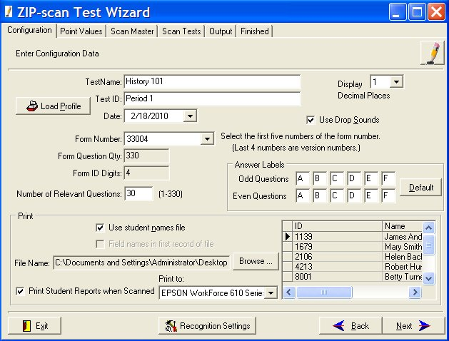

If you check the box in front of Print Student Report When Scanned and select the printer you want to use, each time a student’s test is corrected, that student’s individual report will immediately print on the specified printer. This would allow the student to immediately get their individual report from the printer output tray and return to their desk to assess the results of their test.

Click at the bottom right and the Point Value screen opens.
Point Value

You can enter the same point assignment value for all questions, or you can customize the test to give greater value to some of the questions. Use the tab key to move to sequential blocks that will turn blue, and then just type in the new value.

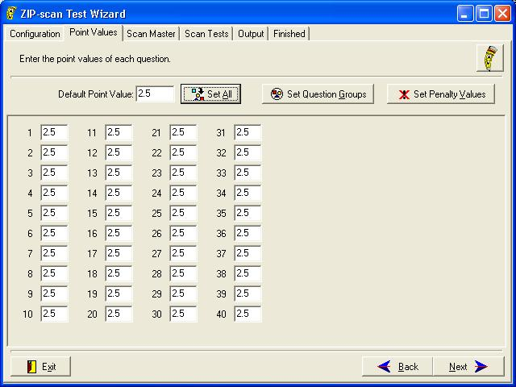

The screen will display a box for every question on the test. You can assign different point values to every question or the same by setting the default and click . Then edit just those individual questions that are to be different.
Click and you will get the screen below listing every question on the test and the penalty point value that you wish to deduct when they provide a wrong answer for a question. The value is positive on the screen, b ut it will be deducted when there is a wrong answer to discourage guessing on the test. If the question answer is blank, then there is no deduction to the score.
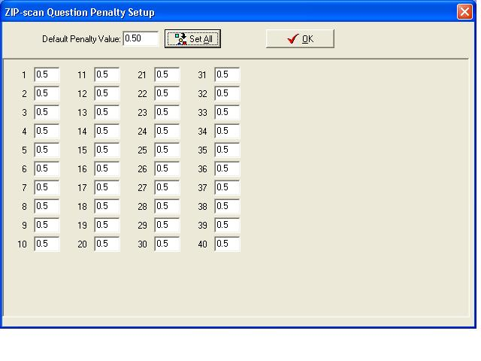

The button will be discussed later in the Advanced Features section of this manual.

Scan Master
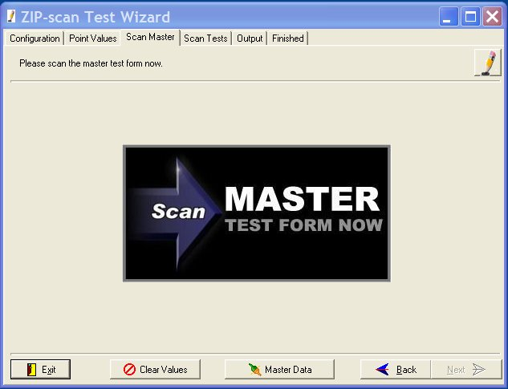

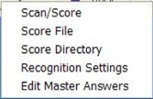

From the Scan Master setup screen, click and a drop down menu will appear. The only option that you need to use now is the top selection: Scan/Score. Select Scan/Score and a Select Folder to Save Image Into screen will appear. Create a new folder for the images that will be scanned and then click .

The Multi Page Scanning screen is displayed. Place the master test form(s) with all of the correct answers marked into the input tray of the scanner. If there is only one scanner accessible to your PC, you are ready to scan the master test form(s). Click and the scanner should initiate the scan of the master test sheet(s). (If no scan occurs, click on the small red image of a scanner at the top left for a drop down menu of all the scanners attached to your PC and pick the scanner that you want to use. If the selection box is blank, either the scanner is not on or is not correctly installed). Then click again. After the scan is completed, the screen will look like the screenshot below:
!

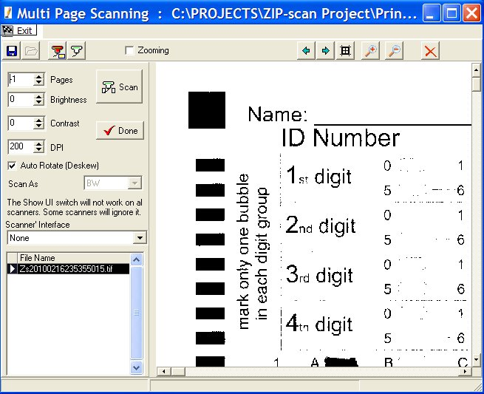

!

You should see the scanned image of the master test form in the large window on the right. There are slider bars on the sides of the image and zoom in/zoom out buttons at the top that enable you to shift the image so you can look at the bubbles that are marked. Are your bubbles dark and are the black squares dark? Even if they are not dark, your scanner should work, but you may need to make an adjustment to the Recognition Settings (discussed later). Please look carefully at the image and remember the appearance of the marks on this page. Enlarge the screen, use the slider bars and the buttons at top of screen to get a good view of the marks on the scanned test sheet. Next click .

The Test Wizard then processes the scan of the master test form(s) and the screen will change as shown below with a one line listing at the top of all the correct answers to the questions. If you have the sound settings turned on, you might hear a "boing" sound, indicating that there was one or more ambiguously marked bubble(s) on the master test form. These will be indicated by a ? in one or more of the cells (shaded in yellow). The master test form must be corrected and re-scanned with no errors to ensure accurate student comparisons to the master. If the scan was complete with no errors, there will not be a sound created. You can then proceed with the student scoring. YOU HAVE JUST SCORED YOUR FIRST MASTER TEST SHEET! Click to go to the Scan Tests screen. If there are any answers that are indicated as ambiguous, you must either correct the master sheet by adjusting the marked bubble darkness, or follow the instructions in the Recognition Settings section that is next.

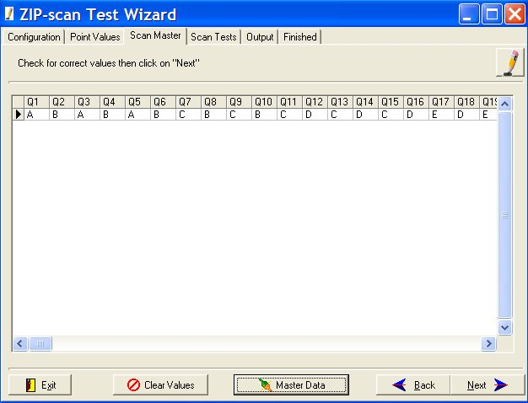

!

Recognition Settings
!
IMPORTANT: If any of the answers are ambiguous, there is a problem that needs to be resolved. (Note: you can edit the screen to correct these answers, but it is best to take the time now to calibrate the scanning function). The scanner should read the master test sheet perfectly. If not, click to display the drop down menu and then select the Recognition Settings option to open the screen as displayed below. (If you are using non-USA size A4 paper, change the PageWidth in inches field to be 8.26 inches).
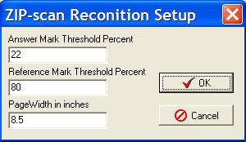

Recall the appearance of the marks on the scanned master test sheet. If the marked bubbles were very dark, then change the Answer Mark Threshold Percent to be 30. If the appearance of the marks was very light, then change the percentage to be 15 or lower. Then click .

Next, click and reload the master test sheet(s) into the scanner. Click select the Scan/Score option and click to scan the sheet again. Click to have the scanned page(s) scored. Inspect the correct answer listing and if it is correct, then proceed by clicking . If there are still problems getting all the question answers to read correctly, go to the end of this User's Guide for additional troubleshooting suggestions.

If the problem is marked bubbles are reading as blank (blue), then decrease the Answer Mark Threshold Percent. If the erased bubbles are being scored as marked (yellow), then increase the percentage.
Click and the Scan Student Test Forms Now screen is displayed.

Scan Tests

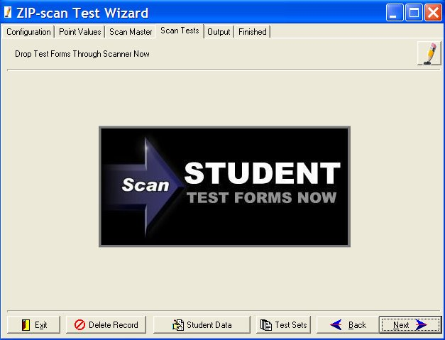

Click at the bottom and in the drop down menu, select the Scan/Score option to bring up the same screen for scanning as used for the master test sheet. This time, if your scanner has an Automatic Document Feeder (ADF), load a stack of student test forms into the feeder and click .
!
Note the -1 value in the Pages field in the upper left of the window below. This -1 value tells the scanner that to enable the ADF feature. If this value is changed to a positive number, the scanner will only scan that number of tests. It is important to leave this value at -1 if you have an ADF!

The scanner should auto feed and scan one test sheet after another. (Note: The demo software program is restricted to only read and score a maximum of five tests). After scanning is completed the screen will look similar to the one below:

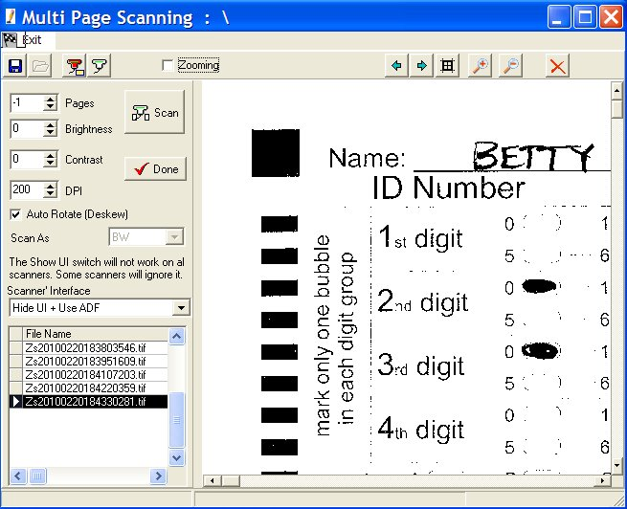

!

This screen is almost identical to the Master Test scan, with the exception that there will be a listing in the left window of each of the tests scanned. The large right window will show an enlarged view of the forms as they are scanned. After the scanner has completed the scan and there are no test forms remaining in the input tray, click . This will start the Test Wizard process which will compare and score the tests based on the Master Test form. After the scoring process is complete, the screen will change and you will see the screenshot shown below.
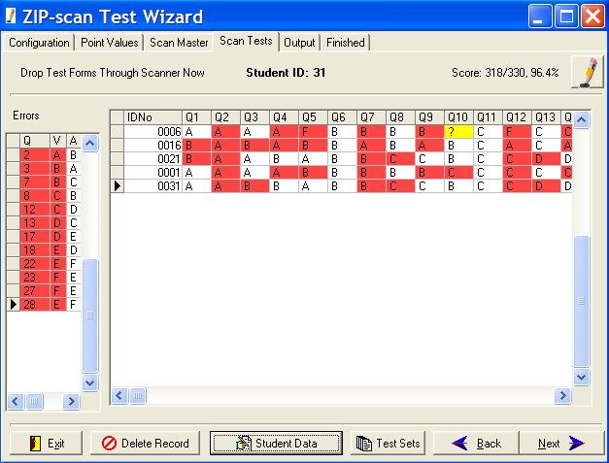
BOINK!
BOINK!

CHIME!

As each student’s test sheet(s) is scored and displayed in the right window, you will hear on the speaker of the PC a pleasant "chime" sound if there are only correct and wrong answers on the test sheet. If you hear an unpleasant "boink" sound, there are questions with a blank response (blue color, hyphen) or an ambiguous (two bubbles marked, yellow color, question mark). Wrong answers are colored red. On the left is a summary of the incorrect responses along with the correct answers listed, and on the top right is the score for the test that has the arrow point opposite its line of data. At the top is the name of the student whose test has the arrow pointed to it if a list of ID numbers and names was created on the second Configuration screen of the software.
The button at the bottom of the screen will be discussed in the Advanced Features section.

Output
Click and the Output screen below is next displayed. This screen has many features that you need to become comfortable using. You can practice using these options over and over and you will always return back to this screen. You will not lose your test data results and this screen until you are done and then click at the lower right corner. You can actually make some changes and see how the changes affect the reports. And, you can go back to the student data screen and process additional test forms and edit the master answers.

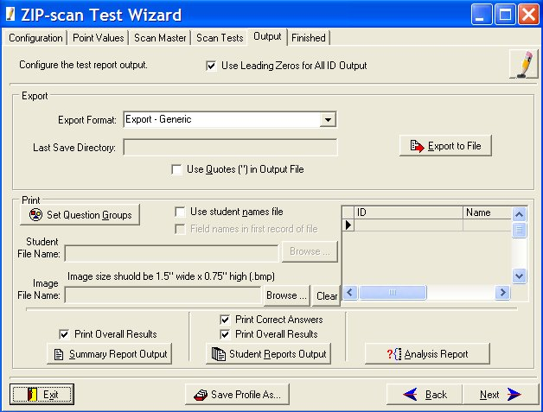

The Print section has a helpful, optional feature that enables the student’s names to be included on the reports. (This is the same as the previous Print section on the first Configuration screen). First, create a .txt data file with the WordPad program included in the Accessories programs of Windows. Input each student’s (ID Number) <tab> (Student Last or First Name) <space> (Student First or Last Name as desired) for all the students who will be taking the test. Use one line for each student.

Click the button and find this file you created and then click . If you are successful, the data will appear to the right with headings of ID and Name.

Check the box Use student names file and the Test Wizard program will compare the student ID numbers on the tests that were scored and will automatically include the name of each student on the reports. The button finds the file location that contains the student’s name and ID number information. The window on the screen will fill in with data to confirm that the data has been successfully selected. The name file must have a .txt extension (.doc file is not acceptable.)

The Image File Name field enables your logo that you have created or have available to be included at the top of your reports to the right of the title opposite the ZIP-scan logo which is on the left. Click to go to the location of your logo (which must be in a .bmp format) and double click on it to have the Test Wizard automatically include your logo on the reports.

Note the Set Question Groups button is discussed in the Advanced Feature Section. This enables you to create question groupings, view the results, and then make additional changes to the groupings and again view the results of the changes in the output reports over and over.

At the very top of the screen in the middle is a box which if un-checked will not use leading zeros for the ID number when printed on the reports. This only applies when you are using less digits than the test form has space to permit. In this instance the student can fill in their ID number at the beginning, middle, or end of the block of bubbles for ID number. But, for the name data file to function, you must use leading zeros for the ID number in the Student File Name listing.
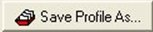
At the very bottom of the screen in the middle is the button which is discussed in the Advanced Features Section.

At the bottom of the screen, there are three reports that can be generated. Each report has options to view a selection, print a selection, or create a .pdf file to save the information in Adobe Acrobat format for later viewing or printing. Please note that you can go back and forth to each selection as needed while you are in this final screen of the Test Wizard and view the results.

The Export section is described in the Advanced Features section and can be skipped for now.
Click on the , , and buttons at the bottom of the screen and view the reports. The reports also include the results per the sub groupings that you created.
Above the button is a check box, which when not checked will delete the printing of the overall summary. Some instructors are totally focused on the question grouping results and do not want the overall results to be included in the report.

Above the button is a similar check box, which when not checked will delete the student’s overall test results leaving only the grouping results. Also, you can uncheck the Print Correct Answers box, then the correct answers will not print next to the 'X' on the student reports which marks the answers which are wrong. This allows the student to try again to choose the correct answer.

Note that if your budget is very tight, and the number of question on a test is also small, it is possible to re-use the test sheets by passing them back to the same students to take the next test by answering on a following sub group of questions. You then program only the sub group of new questions to be displayed and also un-click the button which causes the overall summary to not be displayed. The end result is a report for only the new questions for each student.

The Analysis Report screen provides the ability to select the sections you wish to include in the report. Also, there is an Export Data option to have the file exported in a tab-delimited format for use in Excel or similar programs. (Note that the actual export does not occur until an Output option for the Analysis Report is used). For example: select the View option to trigger the generation of the export file.
When you are completely done, click at the lower right corner of the screen and you will be able to return to the first Test Wizard screen to begin correcting a new test.

Advanced Features

Save/Load Profile (Enables the same test to be scored again with no setup needed)

The Save Profile As and Load Profile options enable you to save the setup of a test with all the selections you have made including the correct answers. This is very helpful if you will be giving the same identical test in the future to different classes. Start by performing a regular test correction per the standard instructions. In the Output screen, click at the bottom of the screen.

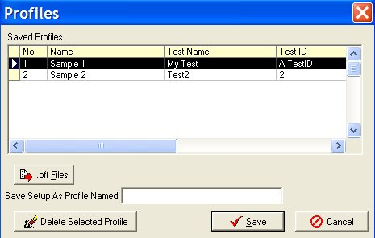

The Saved Profiles Screen pops up and you assign a name in the “Saved Profile As:” blank space for the test you just corrected. The Test Name and Test ID information are automatically filled in. This profile has all the setup selections and the master answers to the test you have just processed.

Now that you have a saved Profile, the next time you need to correct the same test, click on the first Configuration screen, and the setup information will be filled in automatically.
Click to view the data, edit if needed, and move quickly to the Student Data Scoring screen to begin scanning the student’s tests and then scoring them.

You can share a profile with another location by using the .pff Files button which causes the option for Save Selected Profile to .pff File to appear. When selected, you are able to name the file and select a location on your PC’s hard drive where it will be saved. You can then email this .pff file to the another location that has the PrintScanScore software and they can use this same .pff Files button to Load Profile From .pff File option to import the profile.

_______________________________________________________________________________________

Test Sets (Saves raw test data so more can be added later)
Click at the bottom of the Scan Test screen and the Saved Test Sets screen below is displayed.

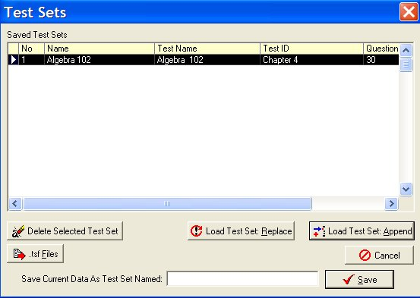

The Test Sets feature enables you save all of the raw test sheet information so you can add the test data later for any students that were absent when the test was first given. (Hint: you must also save the Test Profile details which is discussed in the Advanced Features section.) To utilize Test Sets you must first save your raw data under a name using the entry at the bottom of the screen above. And you must also save the Test Profile which saves all of the configuration data including the master test answers entered for your test.
The steps to recover the saved data for an old test and add new student data is as follows:

- On the Configuration screen, click Load Profile and select the profile name saved. This loads immediately all the setup information for the test including the correct answers. Click to move through this saved information making sure it is correct.
- When you get to the Scan Tests screen, scan the tests for the students that were absent. Their test results will appear on the screen.
- Now click at the bottom of the screen and the screen above appears. Highlight the correct name for the data that you previously saved. Then, click and all of the old raw student data will be added to the absent student data.
- You now have a total file of raw data that includes the entire class and you can create the needed reports on the next Output screen.

Be aware that it may require several minutes for the PC to save all the detailed data if there are a lot of questions and a lot of students. Note that there is a button which allows the listing of raw data highlighted to be saved to a location separate from the ZIP-scan folder, or for loading from a location separate from the ZIP-scan folder. This enables test files from different departments to be combined into an overall result. These .tsf files can be emailed between locations as needed.

_______________________________________________________________________________________

Answer Labels (Changing the letters next to the bubbles)

The Configuration screen has a block where the labels on the even and odd questions can be revised. There are tests that are created by the Houghton Mifflin Publisher which use answers labeled ABCDE for even numbered questions and FGHJK for odd numbered questions. To support this test format, you are able to fill in these values in the Answer Labels section and this custom answer lettering will also be used for the test reports that are generated. Special test forms will be required and you need to create a PDF of the test forms and use a PDF editing program to change the test form letters.

To activate this option fill in the information in the block on the second Configuration screen.

Some tests may utilize numbers instead of letters or use T and F for true and false responses. This type of custom labeling of the response formats is also supported. PDF’s of the test forms can be edited using many programs that are available. As long as the spacing on the form does not change, editing should be fine.

_______________________________________________________________________________________

Set Question Groups (Causes test results for groups of questions to also be reported)

This feature gives you greater visibility on how the students performed in different areas of learning on the test. These groupings will be reported on the Summary Report and the Student Reports after the overall results unless you delete the printing of the overall results by un-checking the box on the Output screen.

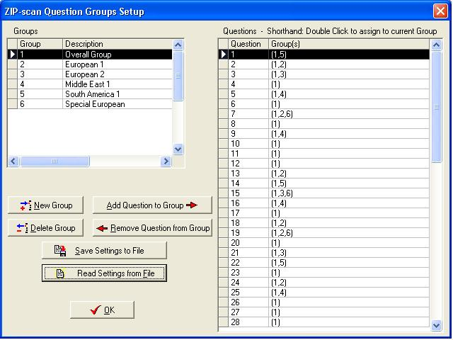

The Questions Grouping feature can be selected in the beginning on the Point Values screen, or at the end on the Output screen. Click and the ZIP-scan Question Groups Setup screen opens.

On the right is a listing of the question numbers with all questions permanently assigned to Group 1: Overall Group. The buttons provided enable you to create new groups and then assign specific question numbers to the new group by simply double clicking on each question number or using the buttons provided.

There are no limits on the number of groups or the number of questions in a group. You can also assign a question to more than one group. After the question grouping assignments are completed, save the settings to your PC so that you can use them again. Be sure to remember which file location on your PC the Test Group Settings (.TGS) have been saved for future reference.

Note that while you are in the Output screen, you can revise the settings, and view how the test data looks in the Summary and Student Reports. And, you can revise the settings over and over until the results in the viewed reports are correct.

_______________________________________________________________________________________

Test Data Files Export

Various clients have requested custom formats for the test data and this Test Data section is about these special requests and the format of the data.

The Export section of the Output screen has a drop down menu of different reports that are available. Choose the report you want in the window, and then click . Browse to the desired destination folder and click . The test file will have the default Name and ID Number you assigned first configuration page at the beginning, or you can change it here if you so desire. Each time an Export to File selection is made, this file is immediately created. It is then fun to immediately go to this location using Windows Explorer (hold down the key on the bottom of the keyboard that has a windows symbol on it and press the “E” key to open an Explorer session). This Export feature enables multiple tests formats to be saved.
The next image has the Export Format: drop down listing shown. Click one of the listed formats for exporting, then click and a browser screen enables you to choose where the exported data is put.
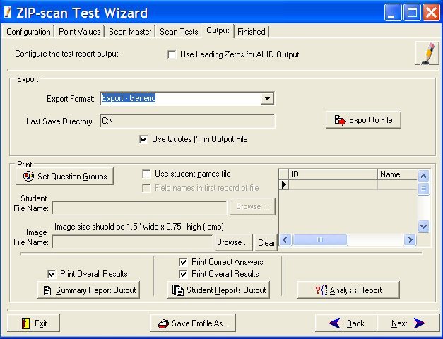

The Export Format: drop down menu has selections for:

Generic and GradeSpeed are identical grade book formats. This format is the most popular and simple. The text file lists on each line the student’s ID Number, a tab, and then their score on the test. This format can also be used for WinSchool® and Grade Machine® grade book programs. Please test your grade book program to see if it works with this simple format and let ZIP-scan know your results.

GradeQuick by Edline uses a fixed spacing file format. The student ID begins in the first space of each line and the student’s test score begins in the tenth space of each line.

Detailed creates a comma delimited data file. It lists by ID number every answer that each student made to every question in sequence. Some instructors use this type of electronic file for their own test correction and analysis using Excel® or other program.

UT SIS 2000+ is an export for Utah schools. Contact ZIP-scan for details.
Summary Report Data (Tab Delimited) and Summary w/Groups (Tab Delimited) create a text data file listing of the Summary Report that has each student’s ID number, name, score, and percentage in a tab format that can be imported into Excel® or other programs. To import the file, start the Excel® program and click on Open and navigate to the data file you want to import and double click on the file. Follow the prompts to select either tab delimited or comma delimited and take the default selections. The data will then appear in individual cells of Excel®.

Individual Test Export (Comma Delimited) creates a .csv (comma separated value) data file listing every student with their ID, their name, their score, and their answers to every question and if their answer is wrong, then the correct answer is listed. This data is automatically imported into Excel® if you have the Excel® program on your PC. This file was created for the instructor that wants the test results in detail for their own Excel® analysis. These files is very adaptable using Excel®.

_______________________________________________________________________________________

CTAPIV (Benchmark Testing Report)
The Benchmark solution is in cooperation with the California Northern CTAP4 organization. Go their website (www.ctap4.net for the Program and Improvement section) at the following URL:

http://www.ctap4.net/using-data/program-improvement.html

In the middle of the page, there is The BENCHMARK Analyzer option as illustrated below.
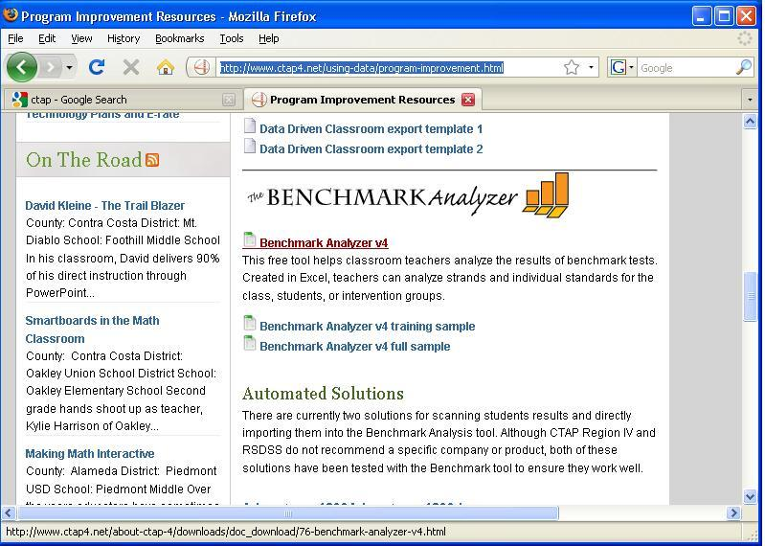

Double click on the first line item Benchmark Analyzer v4 and download the basic Excel® file for the Benchmark Analyzer. This file allows you to edit and assign up to 100 questions each to a specific standard, and those standards can be edited as desired for each of the grades. You will be able to edit them if you remove the protection on each specific page. To do this, open the Excel® file page to be edited, then in the Tools drop down menu, point to Protections and select the Unprotect Sheet option. A window will appear and you type in the password: “improve". Remember that the password will need to be entered to unprotect each of the five pages if you need to do editing. The first page, Standard Entry is often the only page that needs editing.

The CTAP4 organization created the Benchmark Analyzer to support the Curriculum Associates Benchmark Tests that are used in the Northern California schools. To assist with using these tests, there are at the end of their web page a whole series of Excel files which are pre-configured and can be downloaded. If you are using the Curriculum Associates Benchmark Tests you will want to use these Excel® files for exporting the ZIP-scan test results.

When the data is filled in by the ZIP-scan program, the Student Score Excel® page will look like the illustration below. There is space for up to 100 students on the upper row and for up to 100 questions in the left column. The students are identified by ID number and name. The letters listed in the file are the wrong answers that were selected by each of the students when the question was answered incorrectly. If the cell is empty, the student got the answer correct.

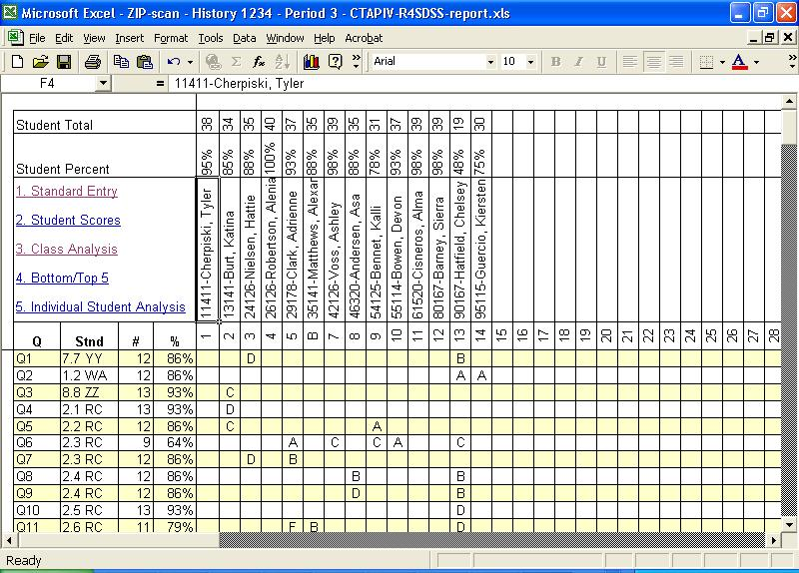

Test Wizard Instructions for Exporting the Test Results into the Benchmark Analyzer Excel File:

- Have the downloaded Excel® file or the edited Excel® file saved in a folder on the hard drive.
- The Excel® file that is to have the ZIP-scan data exported into must not be open on the PC.
- You have corrected all the tests and are on the Configure the test report output screen.
- For the “Export Format” open the drop down selections and scroll to the last format option.
- Select the “Export – CTAPIV – R4SDSS (Excel)” format option.
- Click at the right and navigate to the folder that has the Excel® file that you want the test data exported into.
- Select the .xls file and click , then click .
- A message appears: “A file named: RESUME.XLW already exists in this location. Do you want to replace it? Click YES.
- The test data will be imported automatically into the selected Excel® file and the name of the test data file will be added to this Excel® file name and it will be stored in the same folder as the Excel® format pattern file is stored. You can watch the movement of the scroll tab on the student names as an indicator of status. It can take several minutes if the file is large.
- Go to the Excel® data file location and confirm that the test data was imported correctly.

Registration (Activation)
After the 30 day demo period has expired, the on the Welcome Screen will not function.
Contact us to give us your credit card information verbally over the telephone. Or, send us two separate emails with your credit card information split between the emails for security reasons. We are sorry that we do not have a secure server for entering your credit card information. Email and telephone numbers are listed at the end of this Quick User’s Guide document.

You must provide the Machine ID code number that appears at the top of the Register box screen below.

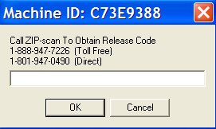

After your credit card payment has been processed, we will use your PC’s Machine ID code to create a Release Code unique to your specific PC. After entering the code, click and the Register Box will disappear. Then exit and restart the program and the button will now be functional.

Troubleshooting

Images
If you cannot scan a page and get an image, then you have a scanner operational problem. Your scanner must be able to function as a scanner using the manufacturer’s supplied drivers before PrintScanScore can function.

You can view the images of the scanned test sheets in the Image folder where you installed the software. If you look closely at the TIFF images, you can usually see why there was a problem with the scoring.

If marked bubbles are being read as blank (blue color, with a hyphen), then you need to decrease the Answer Mark Threshold Percent value until marked bubbles are read properly. (Blue = decrease %)

If there are erasures on a test form that are being read as marks, causing two marks to be read as ambiguous (yellow color with a question mark), then you will need to increase the Mark Threshold Value Percent value so that an erasure will not be identified as a mark. (Yellow = Increase %)
Auto Feed
We had one scanner with an automatic document feeder (ADF) that would not auto feed a stack of test forms. We installed the same driver on a different PC and the ADF worked fine. You may want to try the scanner’s driver program on a different PC if you have a similar problem. Or, download the latest driver from the manufacture’s web site and install to see if it solves the problem.

Drivers
We installed a scanner on a Window 7 PC and the Microsoft drivers for the scanner auto loaded. But, the quality of the images were terrible (little dots all over the image). We then went to the scanner manufacture’s web site and downloaded the latest Windows 7 drivers for the scanner and then perfect scanned images resulted.

Scanners
We have evaluated many all-in-one fax/scanner/printer combination units from Lexmark, HP, Brother, Epson, and Dell and they all worked fine with the PrintScanScore solution. The best value scanner-only product was the Kodak ScanMate i1120 auto 20 sheet-per-minute duplex scanner for less than $400 (www.newegg.com). Alternatively, you could purchase a used scanner and download the drivers from the Internet to get it to function on your PC. We truly believe all TWAIN compliant scanners will function properly with PrintScanScore. And the alternative to TWAIN called WIA usually also works if there is no standard driver in the listing of the scanners attached to your PC that is displayed when the small red scanner shaped button at the top of the scanning screen is clicked.

Macintosh PC
We do not have support for Mac’s. Microsoft has a program called Virtual PC which enables a Mac to function as a Windows PC which our testing indicates works very well.

______________________________________________________________________________________

Please email or call with questions. Especially email as attachments examples of your test sheet images. We want to help you and we are ready to provide assistance.

Email Address: support@ZIP-scan.com

Telephone toll free in USA: 888-947-7226
For outside of the USA: 801-947-0490
Hours: 8:00 AM – 5:00 PM Mountain Time Zone USA, Monday through Fridays

© 2010 ZIP-scan, Inc.

